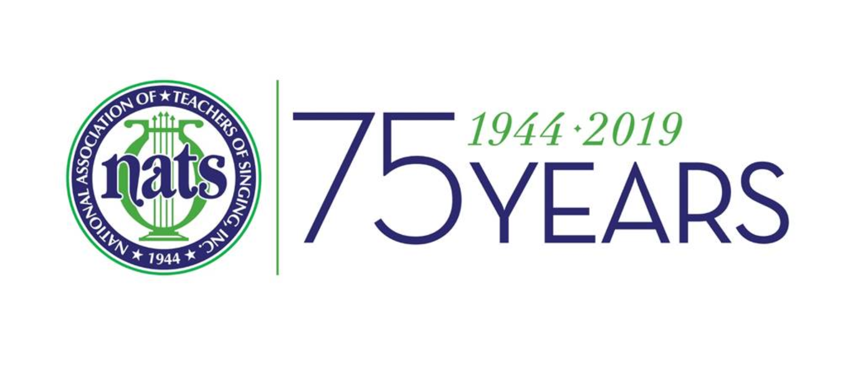
National Association of Teachers of Singing
Founded and incorporated in 1944
The North Carolina Chapter

Dr. DeMar Austin Neal IV - District Governor
Ms. Jennifer Seiger – President
Ms. Wendy Jones - Vice President
Dr. Brittnee Siemon - Secretary Ms. Angela Santucci- Treasurer
Dr. Jennifer Bryant-Pederson - Social Media/Webmaster
Ms. Susan Young-Pianist Liaison Dr. Sally Thomas - Board Member at Large

Call to Order and Reading of Minutes

A meeting of the NC NATS Executive Board was held virtually via Zoom on Thursday, June 11th, 2020 at 12:00pm.

President Jennifer Seiger called the meeting to order at 12:02 pm.

Secretary Brittnee Siemon took roll. In attendance were Angela Santucci, DeMar Austin Neal IV, Jennifer Seiger, Wendy Jones, Brittnee Siemon, Susan Young, Sally Thomas, Jennifer Bryant-Pederson, and Secretary Elect, Gennard Lombardozzi.

Minutes from the spring Executive Board Meeting were read by Secretary Brittnee Siemon and approved.

Treasurer’s Report

Treasurer’s report submitted by Ms. Angela Santucci. .

As of this date, our chapter is in good shape financially. We saved money by not attending a live Regional event.

Vice-President/Audition Chair Report

Ms. Jones offered a year-end and term wrap up.

Record attendance for our NCNATS February auditions.

An email will be sent on or about July 1, 2020, to the entire chapter regarding November auditions to be held on-line. Follow-up correspondence will be handled by new VP/Auditions Chair, Brittnee Siemon.

Returned packets after spring auditions indicated further organization and clarification of mailing addresses and emails is needed. One email and mailing address per member.

Mid-Atlantic Regional Update

Jill Terhaar Lewis of South Carolina Mid-Atlantic Regional Governor transitioned Regional auditions on-line at the eleventh hour in March of 2020 due to the pandemic. Wendy Jones attended a recent recap of these auditions and how NATS at the national level is handling upcoming auditions and events. See attached for more comprehensive notes.

District Governor’s Report

District Governor Neal reported on the membership and collaborative pianist recruitment effort. 169 active members, 8 collaborative pianist members. Collaborative pianists have seen a significant increase in membership over the past two years.

Social Media/Webmaster Update

Dr. Pedersen indicated nothing new to report at this time.

New hand-book and by-laws will be posted to the website.

New Business

Ms. Seiger discussed at great length the future of auditions for the coming fall and beyond in light of the current pandemic. Since it was decided to move forward with auditions on-line, there are a lot of unknowns at this point. A proposed schedule will be sent out after July 1, and the current slate of officers rotate to their new positions. Time-line, accompanist/judge/singers schedules, video up-loads and their formats, awards distribution, payment, etc-all facets of the on-line auditions to be considered. Discussions are on-going at this time.
The current and future mission and vision of the NCNATS chapter was also discussed. Growing membership, building relationships, and establishing a clear delineation of responsibility at each level of leadership are three key approaches to the NATS organization at the state, regional, and national levels.

Board will have another virtual meeting in August and then move forward with a concrete approach.

Ms. Jennifer Seiger moved that the meeting be adjourned. Meeting was adjourned at 1:23pm.

Upcoming Dates

NATS Student Auditions: North Carolina Chapter Fall Conference: Music Theater and CCM Categories
November 13-14, 2020 VIRTUAL AUDITIONS
SCHEDULE AND INFORMATION TBA
​NATS Student Auditions: North Carolina Chapter Spring Conference: Classical Categories
​INFORMATION TBA

NATS Regional Student Auditions: Mid-Atlantic Region
INFORMATION TBA

